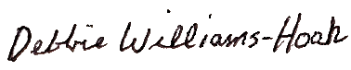

Presented To

~ Name~

Fall 2021

Honorable Mention All-State

Division 4

MIGCA President

Coach